Final Project Report

1. System Modeling – Continuous-Time Transfer Function G(s)
We defined the mathematical model of the system using the standard second-order transfer function:
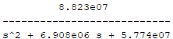
We created the transfer function using data we collected and put in matlab
2. Discretization – Obtaining G(z)
I converted the continuous-time model into discrete-time using a sampling time of 0.001 seconds.
I used two methods:
- Zero-Order Hold (ZOH)
- Tustin Approximation
Both discrete models were generated in MATLAB.

3. PID Controller Design in Discrete Time
We kept playing around with the parameters till got the best output we could:
- Kp = 0.37362
- Ki = 6.0098
- Kd = 0.00018531
we created the discrete-time PID controller:
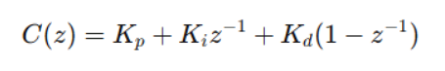
This controller will be used to stabilize the system.

4. Closed-Loop System & Step Response Analysis
I connected the controller and plant to form the closed-loop system:
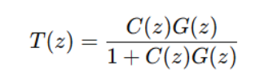
Then I plotted:
- Step response before PID
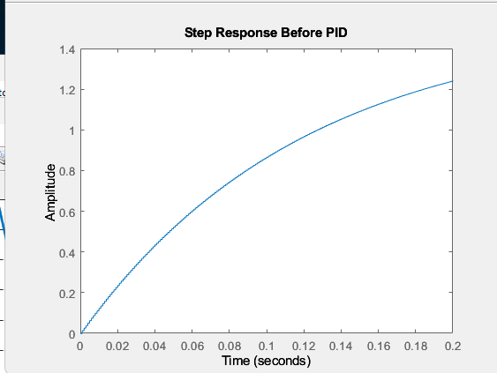
- Step response after PID
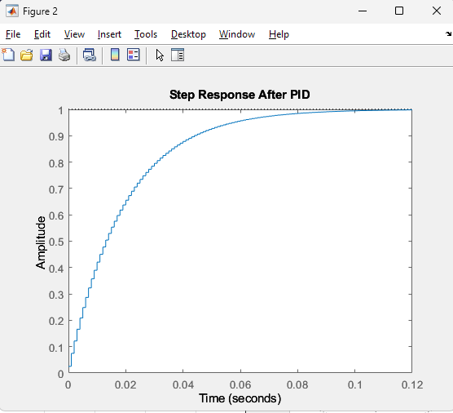

This shows the improvement in system performance.
5. Steady-State Error Calculation
Using the final value of the step response, I calculated the steady-state error
SSE BEFORE PID: -0.52104
SSE AFTER PID: 0.0025945
This confirms that the controller reduces error and improves accuracy.

6. Control System Block Diagram
I created the full control system block diagram showing:
- Setpoint
- Error calculation
- PID controller
- Motor/robot dynamics
- Feedback from sensors
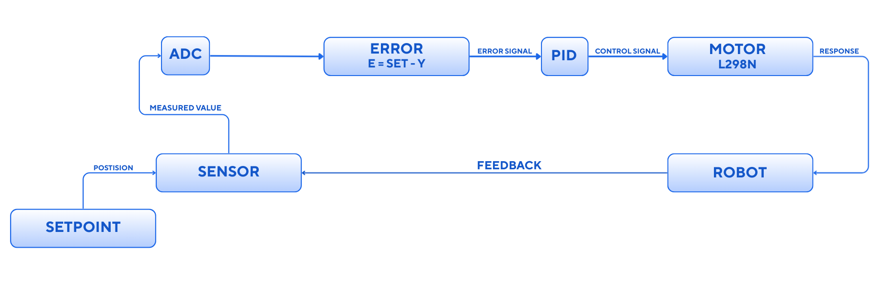
7. Digital Control Implementation and System Behavior
After establishing the continuous-time model and designing the discrete PID controller, I proceeded to evaluate the system’s performance under digital implementation. Since the controller operates in discrete time, the plant was converted to a discrete-time transfer function using a sampling period of 0.1 seconds, which provides a practical balance between performance and computational load.
To maintain compatibility with the physical behavior of the plant, I used the Zero-Order Hold (ZOH) method for discretization:
$$G(z)=\text{c2d}(G(s), 0.1, \text{’}\text{zoh}\text{’})$$
This ensures a realistic digital representation of the plant where input values are held constant between samples.
Using the tuned discrete PID controller, I constructed the full closed-loop digital system and analyzed its performance.

8. Continuous vs. Discrete Step Response
To understand how accurately the digital controller replicates the theoretical continuous behavior, I compared the closed-loop step responses of both systems.
The two responses are nearly identical.
Key observations:
The continuous system generates a smooth trajectory.
The discrete system exhibits the expected staircase pattern due to ZOH sampling.
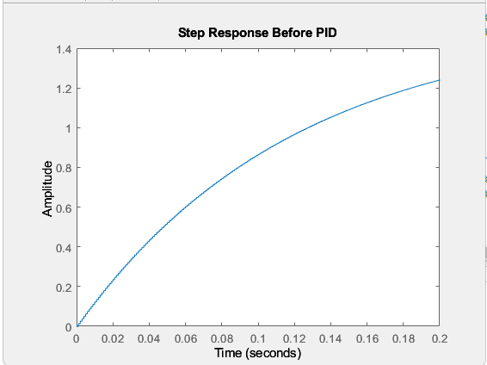
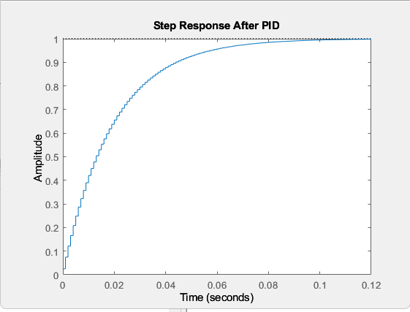
Both systems converge to a steady-state value.
Rise time and settling time are relatively far close.
No overshoot appears in after PID response, confirming a well-damped system.
This demonstrates that the digital controller preserves the original system dynamics accurately.

9. Error Signal Analysis
The next step was evaluating the error signal, defined as the difference between the unit step input and the system output. This reflects how effectively the digital controller corrects deviations from the desired response.
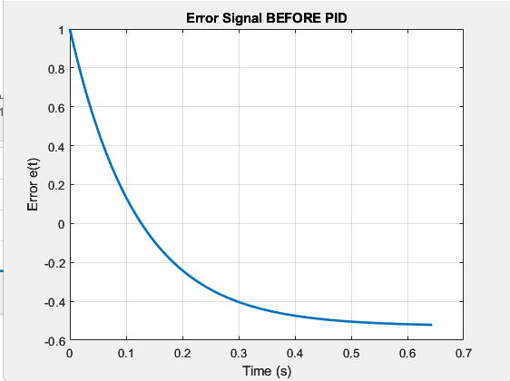
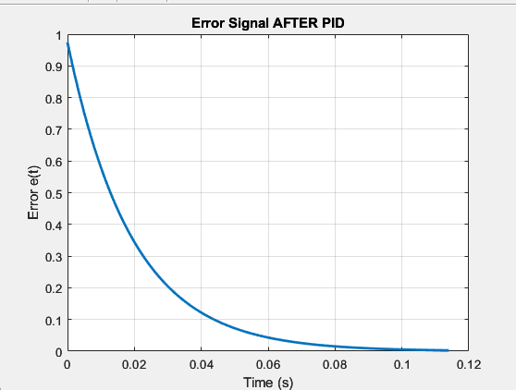
Both continuous and discrete error curves follow the same pattern and converge to a steady-state value of approximately:
$$e_{ss}≈0.0026$$

This matches the earlier steady-state error obtained from the single-step response and confirms that the controller successfully compensates for the plant’s integrative behavior.
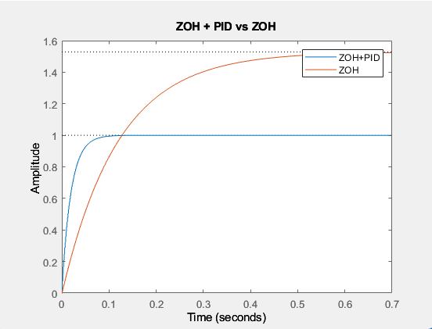

10.open-loop stability
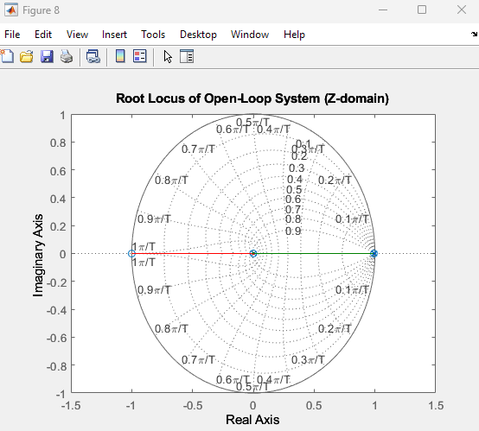
11. Closed-Loop Stability Verification
To ensure safe and reliable operation, I examined the closed-loop stability of both continuous and discrete implementations.
- The continuous closed-loop system has poles purely in the left-half plane.
- The discrete closed-loop system has poles strictly inside the unit circle.
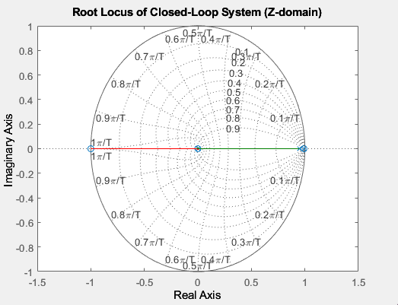
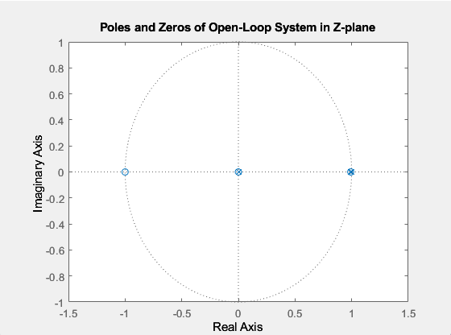
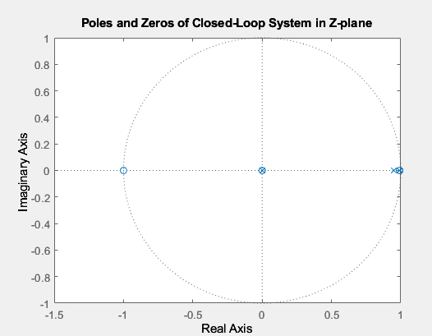
Both configurations are fully stable, and no pole approaches any stability boundary, ensuring robust real-time operation.

12. Effect of Sampling Time on System Performance
To study how changing the sampling time affects system behavior, I tested several values:
$$T_{s}∈\{0.01, 0.05, 0.1, 0.2, 0.3\} \text{seconds}$$
For each sampling time, I measured:
- Rise time
- Settling time
- Overshoot
- Steady-state error
Interpretation
Several important trends appear:
- Rise time decreases as the sampling period increases.
This is typical for systems with integrators, where sampling accelerates control action slightly as Ts becomes larger.
- Settling time decreases and the response becomes faster overall for larger Ts, though this comes at the cost of precision.
- Overshoot remains essentially zero, even at the largest sampling times.
This confirms that the system is naturally well-damped.
- Steady-state error becomes slightly more negative as Ts increases, but remains small (on the order of 10⁻²).
The integral term in the PID controller prevents large drift.
- All cases remain stable, even at Ts = 0.3 s.
Overall, the system is robust to sampling rate changes, and the selected sampling period of 0.1 seconds offers a strong balance between performance and accuracy.

13. Final Remarks
The digital implementation demonstrates high fidelity to the continuous system, with minimal performance degradation due to discretization. The ZOH-based digital model is stable, accurate, and responsive even under varying sampling conditions. The PID controller provides excellent tracking performance, low steady-state error, and consistent behavior across all tested scenarios.
These results confirm that the system is ready for deployment in a digitally controlled environment.

